ECE 465

Project 1

By: Vincent Guevara, Tianhui Xu, Toan Tran

Date: March 1, 2019

**Functionality:**

To run the server, we put it on the mason.gmu.edu server and ran the HTPP_Server.py script. This allowed us to connect to our server by using mason.gmu.edu:1100/index.html. Our port is 1100 and the html file is index.html. We also added some CSS style and images to see the full potential of the server. When a browser connects to the server, the **clientthread** routine continuously run until it sends all the data of HTML, CSS, and images. To implement the multithread, we used **thread.start_new_thread** to keep track of all the threads created. After each thread has finished sending data it exits and when the browser refreshes the page, a new thread is created. To implement the client, we made a simple script that takes in 4 command line arguments: client, host name, port, file name. To request data from the server we just run a request string that consists of (GET filename HTTP/1.1). This tells the server to return data of the file given. If file was not found, client will inform user file was not found.

**Running the server**

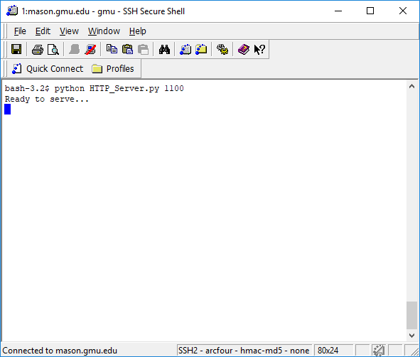

**Connecting to mason.gmu.edu:1100/index.html**

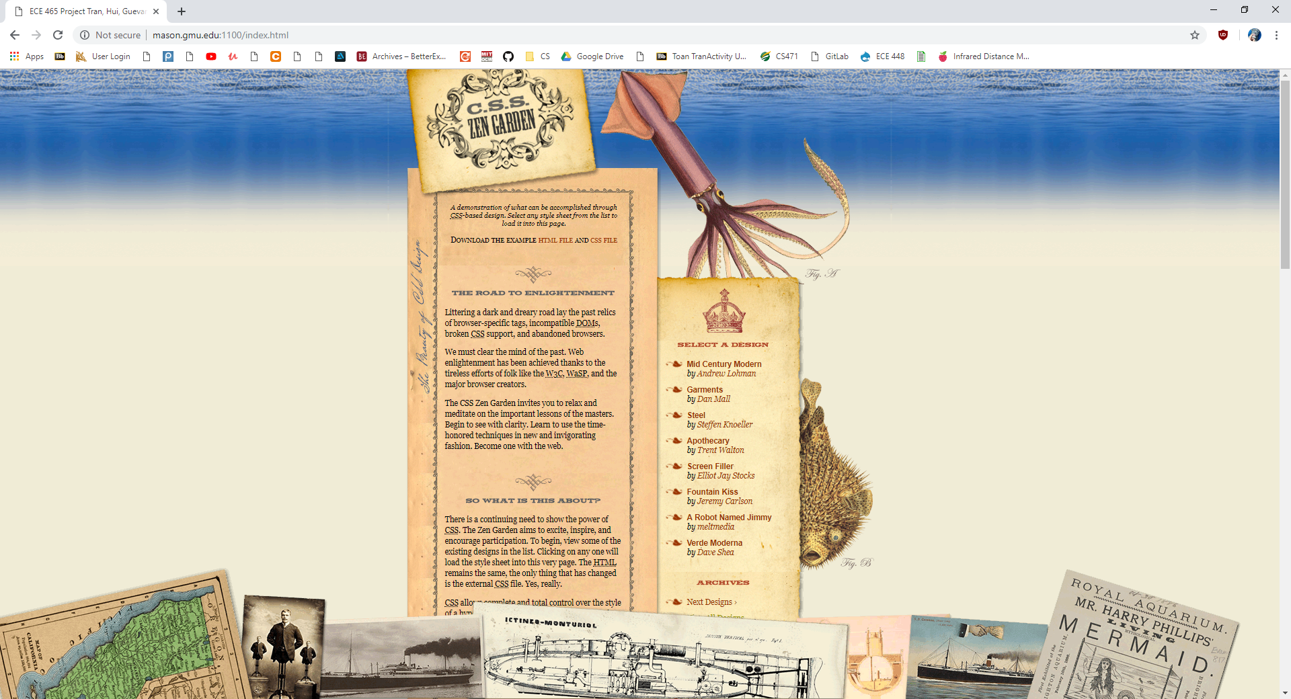

We implemented an HTML file with pictures and CSS so there are a lot of data to send. Each file is sent through a thread.

**Server output**

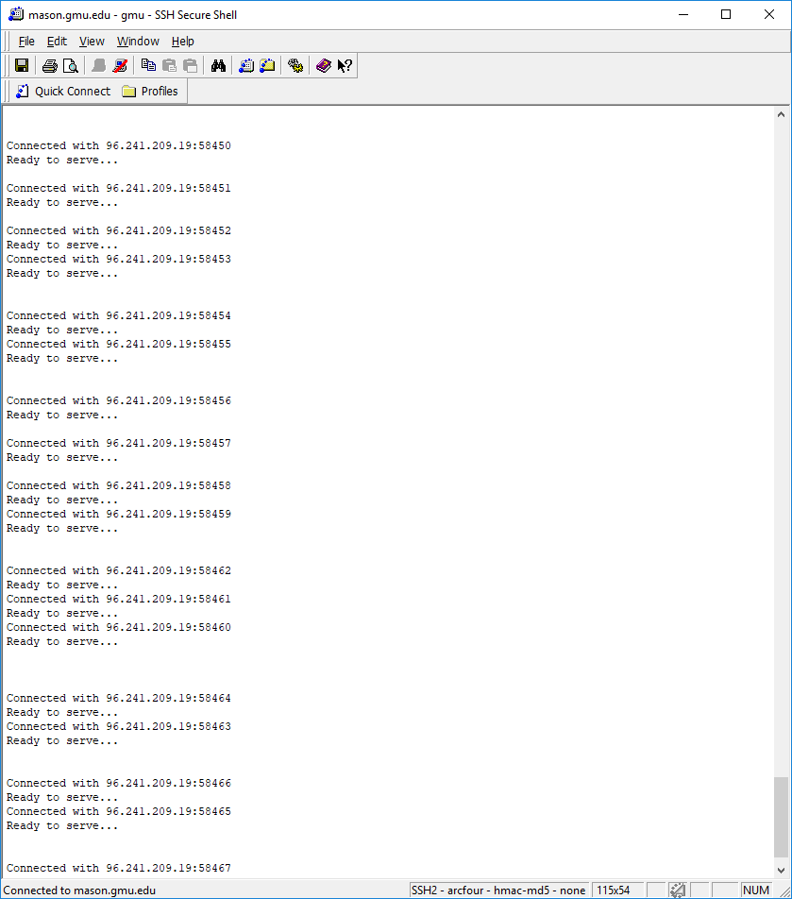

This output consists of one single run, there were many reconnections because we had a lot of pictures on the webpage.

**Client to Server**

Configurations used to input command line arguments in PyCharm

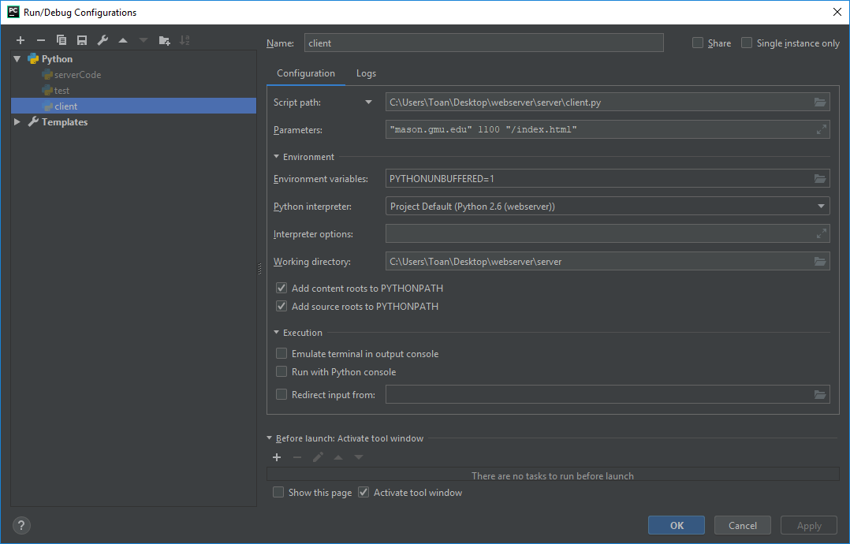

**Output**

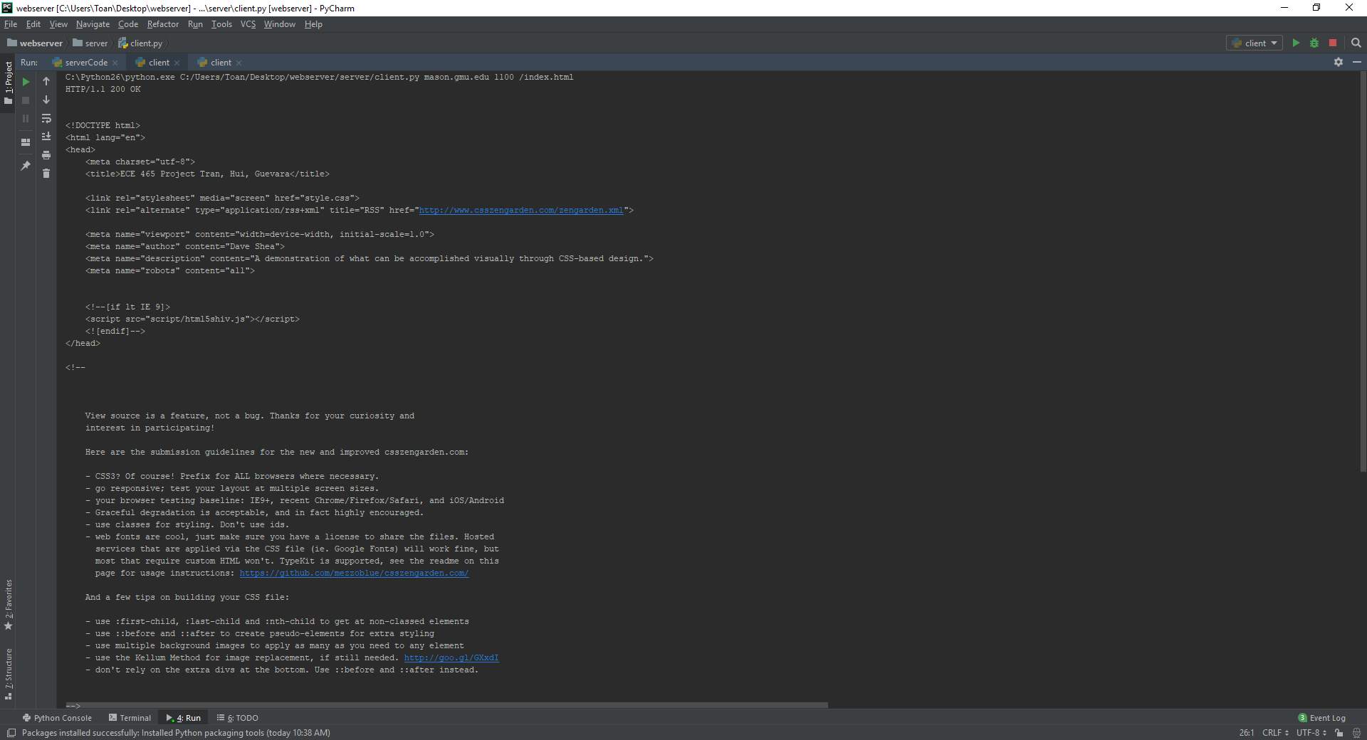

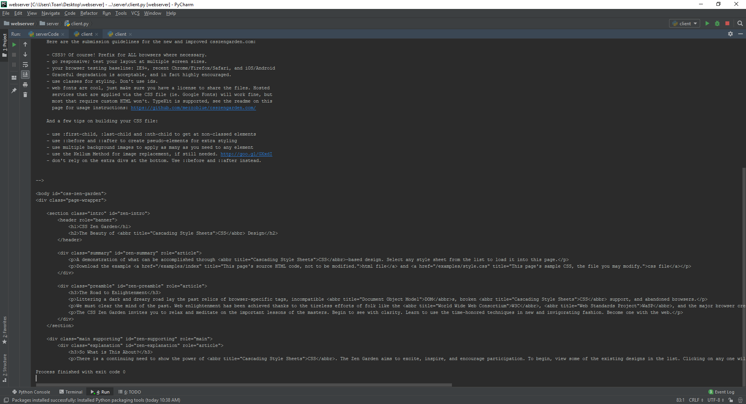

This output to the terminal is the code for the HTML file, we requested the HTTP for the HTML file here.

**Wireshark**

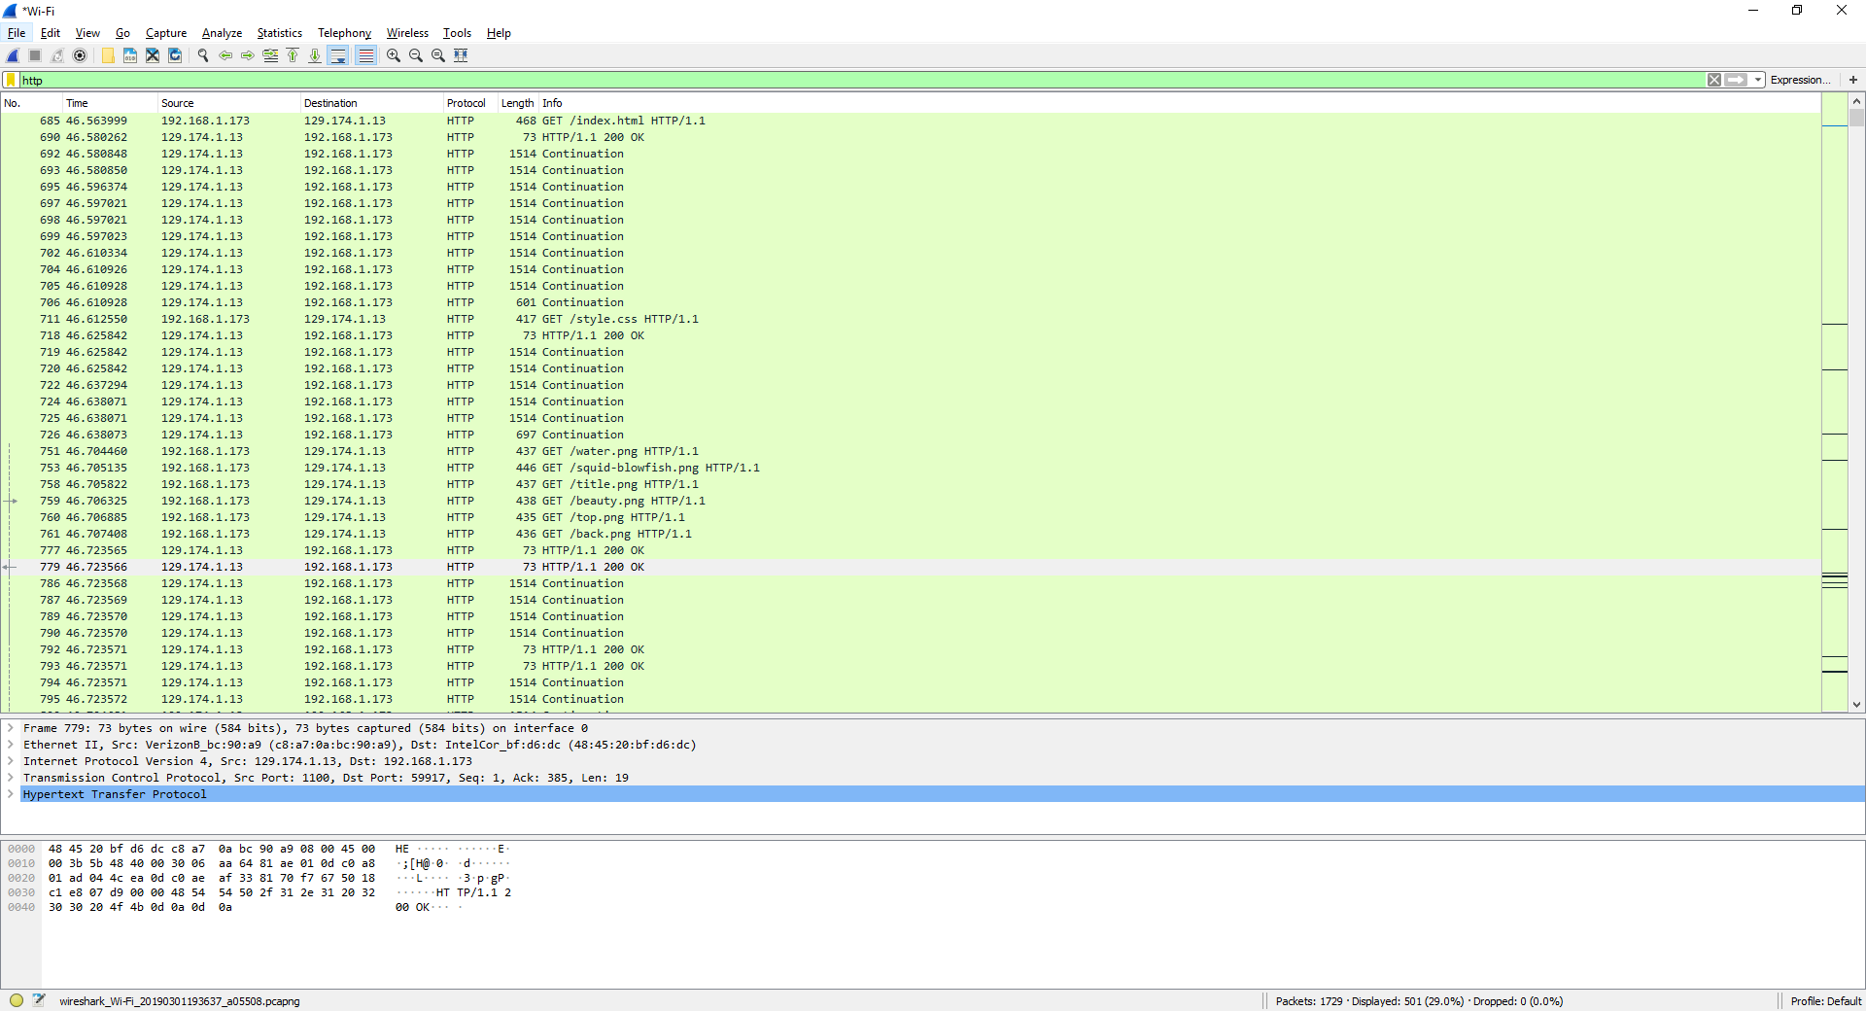

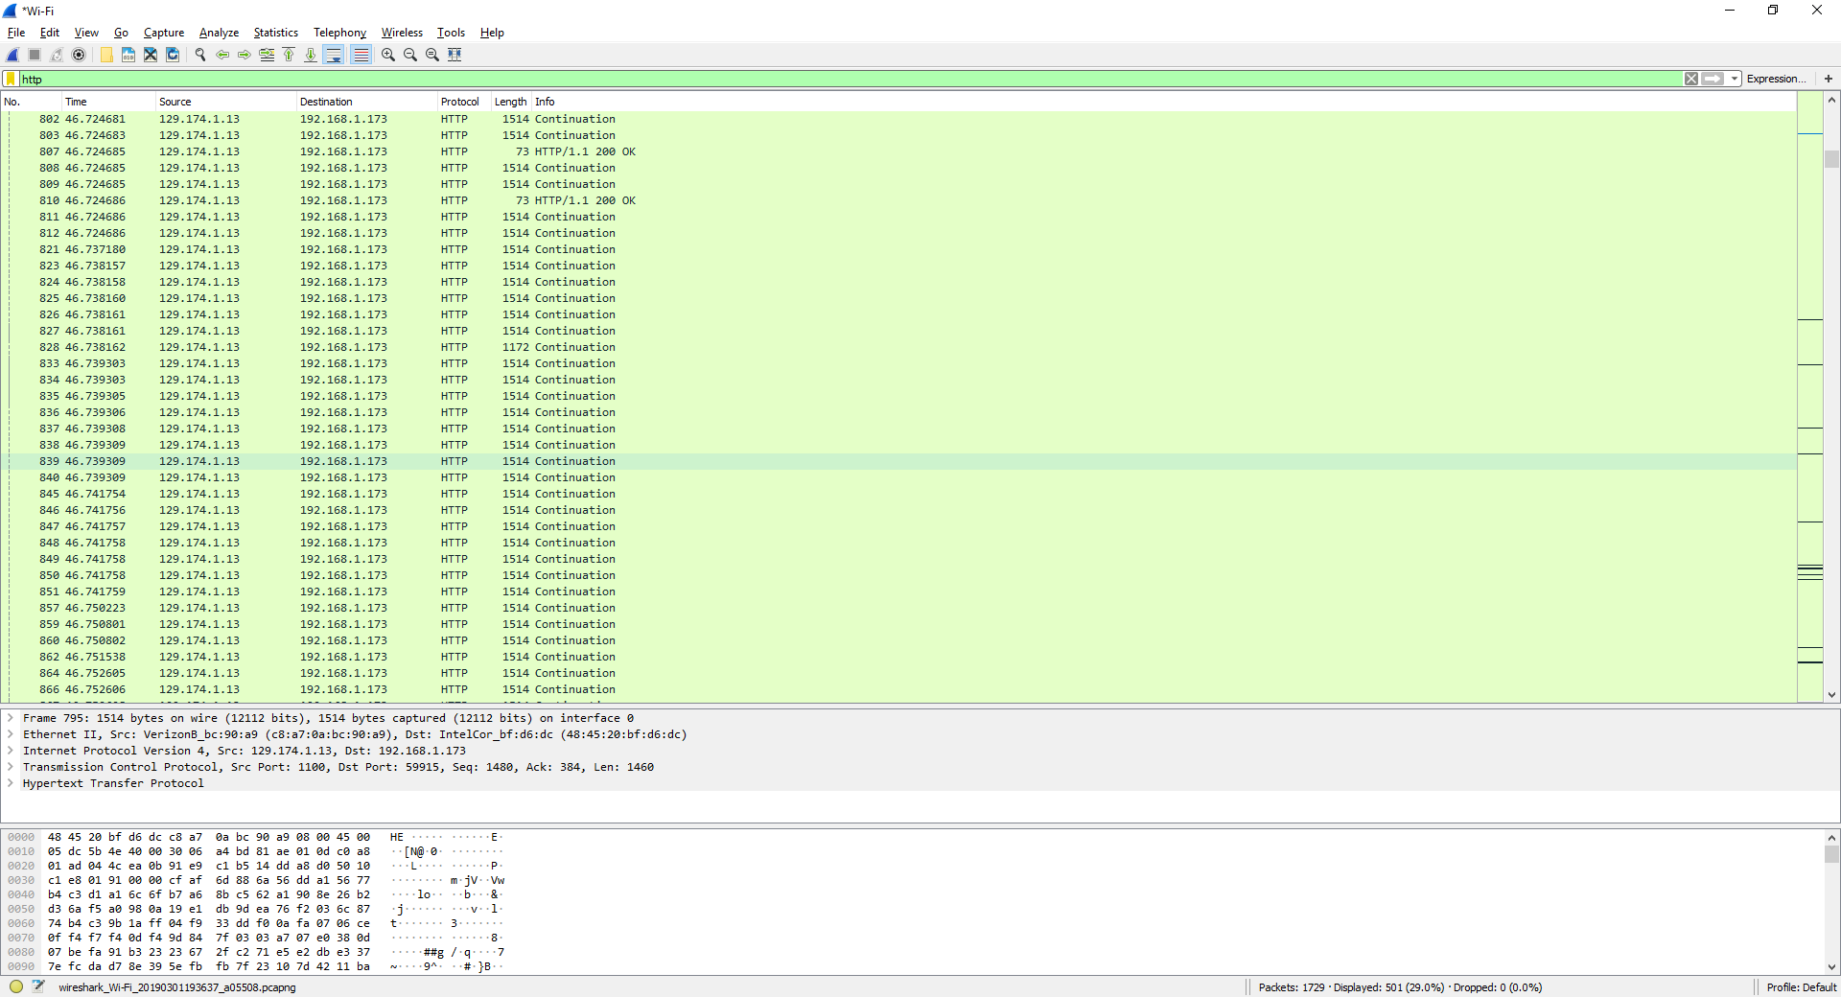

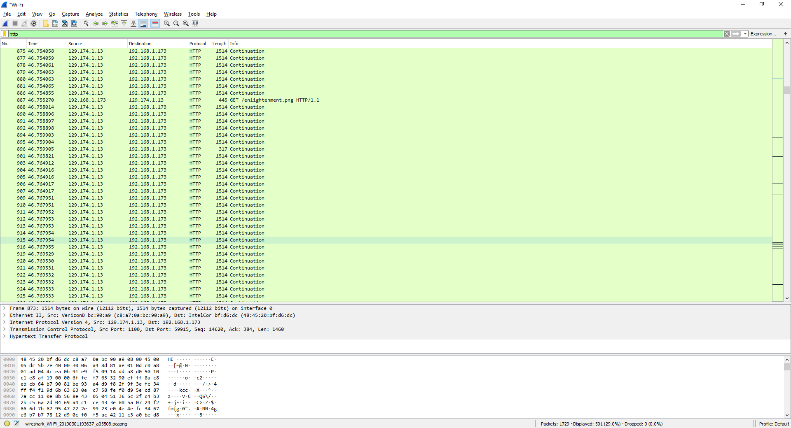

This output is from all the HTPP requests sent from the browser (Google Chrome) to the server on mason’s server. From the capture we can see all the different time the browser requested the data for picture, CSS, or HTML. They all requested these using GET filename HTTP/1.1.